**Task # 1:** Write an assembly program that Read and Print Hello world.

**Code:**

.data

InputHint: .asciiz "Enter Your Name:\n" #Input Hint

HelloWorld: .asciiz "Hello World" # hello world

readString: .space 20 # reserve space for takin input

.text

la $a0,InputHint # load arguemnt Input hint

li $v0,4 #print Input Hint

syscall

li $v0,8 # Take input Name

la $a0, readString # reserve space in arguemnt

li $a1,20 # take input and save it in argument 1

syscall

la $a0,HelloWorld #load hello world

li $v0,4 #print hello world

syscall

**Output:**

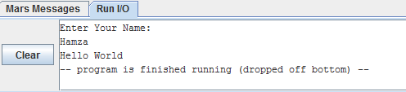

**Task # 2:** Write an assembly program that add two numbers.

**Code:**

.data

Num1: .word 50 #hard coded value 1

Num2: .word 20 # Hard coded value 2

OutPutHint: .asciiz "Sum is :"

.text

lw $t0,Num1 # load value 1 in temporary register

lw $t1,Num2 # load value 2 in temporary register

add $t2,$t1,$t0 # add values and store in another temp register

la $a0,OutPutHint # load OutPut Hint

li $v0,4 #print put put hint

syscall

move $a0,$t2 #move sum to arguemnt register

li $v0,1 #print sum

syscall

**Output:**

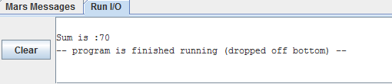

**Task # 3:** Write an assembly program that subtract two numbers.

**Code:**

.data

Num1: .word 50 #hard coded value 1

Num2: .word 20 # Hard coded value 2

OutPutHint: .asciiz "Subtract is :"

.text

lw $t0,Num1 # load value 1 in temporary register

lw $t1,Num2 # load value 2 in temporary register

sub $t2,$t0,$t1 # subtract values and store in another temp register

la $a0,OutPutHint # load OutPut Hint

li $v0,4 #print put put hint

syscall

move $a0,$t2 #move subtract to arguemnt register

li $v0,1 #print subtract

syscall

**Output:**

